In placing this order you consent to Wood Street Mission sharing your details with David Luke Ltd
Uniform will be delivered to your home and is subject to availability
Parent/Carer Name |  |  |  |  |  |  |  |  |  |  |  |  |  |  |  | 
Girls Uniform Pack |  |  |  |  |  | Parent/Carer Address
x4 Polos OR x4 Blouses
x1 Skirt OR x1 pair trousers
x1 Sweatshirt |  |  |  |  |  | Postcode:
Email Address |  |  |  |  |  |  |  |  |  |  |  |  |  |  |  | 2026
Girl's Date of Birth |  |  |  |  |  |  |  |  |  | (Circle/highlight appropriate size or age)
Please return the completed order form to Wood Street Mission
Item |  |  |  |  | Colour(Circle Appropriate)C |  |  |  |  | Size |  |  |  |  | Qty
Girl's Senior Trousers  1 pair each girl |  |  |  |  | Black Grey |  |  |  |  | Girl's Senior trousers (13yr+) order by Waist measurement. |  |  |  |  | Length  Short Regular  Long
 |  |  |  |  |  |  |  |  |  | 27" 28" 29" 30" 32" 34" 36" 38" |  |  | Regular leg or Slim leg |  | Length  Short Regular  Long | 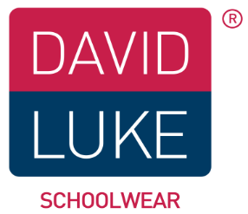
Girl's Junior Trousers  1 pair each girl |  |  |  |  | Black Grey |  |  |  |  | Girl's Junior trousers order by age.
 |  |  |  |  |  |  |  |  |  | 3/4 4/5 5/6 6/7 7/8 8/9 9/10 10/11 11/12 12/13
Girl's Senior Skirt  1 skirt each girl |  |  |  |  | Navy Grey Black |  |  |  |  | Girl's Senior skirt (13yr+) order by waist measurement |  |  |  |  | Length 18" 20" 22" (24" for larger) | Pleated
 |  |  |  |  |  |  |  |  |  | 22” 24” 26” 28" 30" 32” 34” 36” 38” 40” |  |  |  |  | Length 18" 20" 22" (24" for larger) | Straight
Girl's Junior skirt  1 skirt each child |  |  |  |  | Navy Grey Black |  |  |  |  | 3/4 4/5 6/7 8/9 9/10 11/12 12/13
Poloshirt  4 for each Girl |  |  |  |  | White Red SkyBlue Gold BottleGreen |  |  |  |  | 3/4 4/5 5/6 7/8 9/10 11/12 12/13 34"(S) 36"(M) 38"(L) 42"(XL)
Sweatshirt  1 for each girl |  |  |  |  | Navy Red Royal BottleGreen Maroon Black |  |  |  |  | 3/4 4/5 5/6 7/8 9/10 11/12 12/13 34"(S) 36"(M) 38"(L) 42"(XL)
Long Sleeve Blouse  packs of 2 |  |  |  |  | White Blue |  |  |  |  | 3/4 4/5 5/6 6/7 7/8 8/9 9/10 10/11 11/12 12/13 32" 34" 36" 38" 40”
Short Sleeve Blouse  packs of 2 |  |  |  |  | White Blue |  |  |  |  | 3/4 4/5 5/6 6/7 7/8 8/9 9/10 10/11 11/12 12/13 32" 34" 36" 38" 40”
 | Size Guide
 | Age | Boys Trousers | Girls Trousers | Skirts |  |  | Polo/Sweats | Shirts (collar) | Blouses (chest) |  |  | 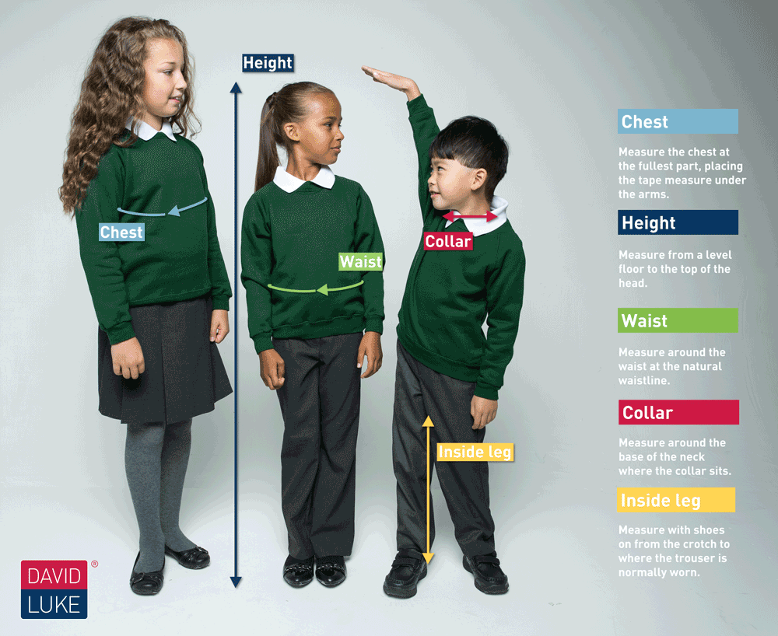
 |  | 20" | 20" |  |  |  | 18" | 10.5"
 | 3/4 | 20" | 20" | 20" |  |  | 20" | 11" | 22"
 | 4/5 | 21" | 21" |  |  |  | 22" | 11"
 | 5/6 | 22" | 21" |  |  |  | 24" | 11.5" | 24"
 | 6/7 | 22" | 22" | 22" |  |  | 24" | 12"
 | 7/8 | 23" | 22" |  |  |  | 26" | 12" | 26"
 | 8/9 | 24" | 23" | 24" |  |  | 26" | 12.5"
 | 9/10 | 25" | 24" |  |  |  | 28" | 13" | 28"
 | 11/12 | 27" | 25" | 26" |  |  | 30" | 13" | 30"
 | 12/13 | 28" | 26" |  |  |  | 32" | 14" | 32”
 | 13 | 29" | 27" | 28" |  |  | 34" Small | 14" | 34"
 | 14 | 30" | 28" |  |  |  | 36" Medium | 15" | 36"
 | 15 | 32" | 29" | 30" |  |  | 38" Large | 15" | 38"
 | 16 | 34" | 30" |  |  |  | 42" X Large | 16" | 40" |  |  |  |  |  |  |  | *Ages are intended as a Guide*
Order Girl's Senior Trousers by waist measurement, with a choice slim leg or regular leg Girl's Junior Trousers by age with a choice slim fit or regular fit

Order Order Girl's Senior Skirts by waist measurement and by length 18" 20" 22" and for larger size only 24" Order Girl's Junior Skirts by age
 | Blouses and Shirts are in packs of 2 you may order 2 packs of 2 in any combination for each child (you will receive 4 blouses or shirts for each Child)

