In placing this order you consent to Wood Street Mission sharing your details with David Luke Ltd
Uniform will be delivered to your home and is subject to availability |  |  |  |  |  |  |  |  |  |  |  |  | 
Parent/Carer Name
Boys Uniform Pack |  |  | Parent /Carer Address |  |  |  |  |  |  |  |  |  | 
Boys Uniform Pack
x4 Polos OR x4 Shirts
x1 pair trousers
x1 Sweatshirt |  |  | Postcode:
Email Address |  |  |  |  |  |  |  |  |  |  |  |  | 2026
Boys Date of Birth: |  |  |  |  | (Circle/highlight appropriate size or age)
Please return the completed order form to Wood Street Mission
Item |  |  | Colour (Circle Appropriate) |  | Size |  |  |  |  |  |  | Qty
Boys Senior Trousers 1 pair each boy |  |  | Black Grey |  | Boys Senior trousers (13yr+) order by Waist measurement. |  |  |  |  |  |  | Length  Short Regular  Long | 
 |  |  |  |  | 29" 30" 31" 32" 34" 36" 38" |  |  |  |  |  | Regular leg or Slim leg | Length  Short Regular  Long
Boys Junior Trousers 1 pair each boy |  |  | Black Grey |  | Boys Junior trousers order by age.
 |  |  |  |  | 3/4 4/5 5/6 6/7 7/8 8/9 9/10 10/11 11/12 12/13
Poloshirt  4 for each boy |  |  | White Red SkyBlue Gold BottleGreen |  | 3/4 4/5 5/6 7/8 9/10 11/12 12/13 34"(S) 36"(M) 38"(L) 42"(XL)
Sweatshirt  1 for each boy |  |  | Black Navy Red Royal BottleGreen Maroon |  | 3/4 4/5 5/6 7/8 9/10 11/12 12/13 34"(S) 36"(M) 38"(L) 42"(XL)
Long Sleeve Shirt packs of 2 |  |  | White Blue |  | 3/4 4/5 5/6 6/7 7/8 8/9 9/10 10/11 11/12 12/13 14 15 16
Short Sleeve Shirt packs of 2 |  |  | White Blue |  | 3/4 4/5 5/6 6/7 7/8 8/9 9/10 10/11 11/12 12/13 14 15 16
Size Guide
Age | Boys Trousers | Girls Trousers | Skirts | Polo/Sweats |  | Shirts (collar) |  | Blouses (chest) |  | 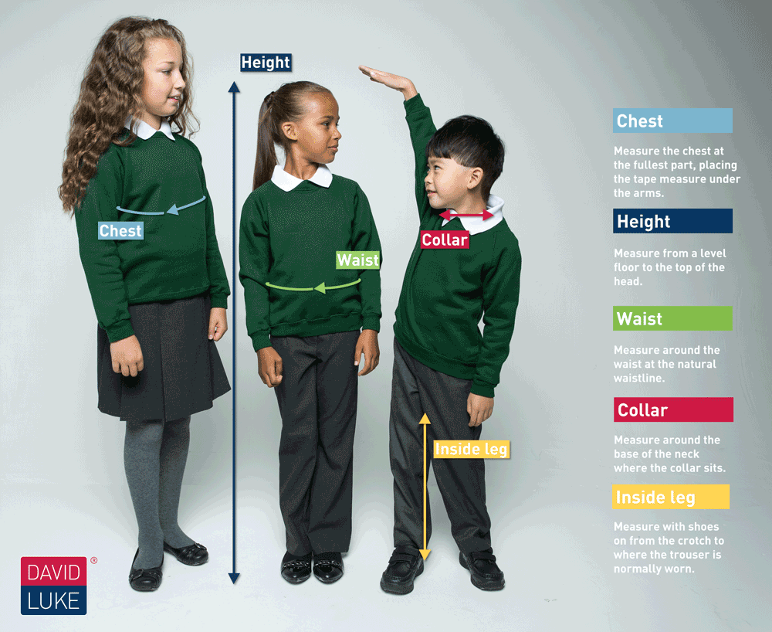
 | 20" | 20" |  | 18" |  | 10.5"
3/4 | 20" |  | 20" | 20" |  | 11" |  | 22"
4/5 | 21" | 21" |  | 22" |  |  |  | 22"
5/6 | 22" |  |  | 24" |  | 11.5" |  | 24"
6/7 |  | 22" | 22" |  |  | 12" |  | 24"
7/8 | 23" |  |  | 26" |  |  |  | 26"
8/9 | 24" | 23" | 24" |  |  | 12.5" |  | 26"
9/10 | 25" | 24" |  | 28" |  | 13" |  | 28"
11/12 | 27" | 25" | 26" | 30" |  |  |  | 30”
12/13 | 28" | 26" |  | 32" |  | 14" |  | 32”
13 | 29" | 27" | 28" | 34" Small |  |  |  | 34”
14 | 30" | 28" |  | 36" Medium |  | 15" |  | 36”
15 | 32" | 29" | 30"32”  34”36”  38”40” | 38" Large |  |  |  | 38"
16 | 34" | 30" |  | 42" X large |  | 16" |  | 40”

