In placing this order you consent to Wood Street Mission sharing your details with David Luke Ltd
Uniform will be delivered to your home and is subject to availability
Parent/CarerName
Parent/Carer Address
 |  |  |  |  |  |  |  |  |  | Postcode:
Telephone Number |  |  |  |  |  |  |  |  |  |  |  |  |  | 2024
Girl's Date of Birth |  |  |  |  |  |  |  | (Circle/highlight appropriate size or age)
Please return the completed order form to Wood Street Mission
Item |  |  |  |  | Colour (Circle Appropriate) |  |  | Size |  |  |  |  | Qty
Girl's Senior Trousers  1 pair each girl |  |  |  |  | Black Grey |  |  | Girl's Senior trousers (13yr+) order by Waist measurement. |  |  |  |  | Slim or Regular leg
 |  |  |  |  |  |  |  | 27" 28" 29" 30" 32" 34" 36" 38" |  |  |  |  |  | 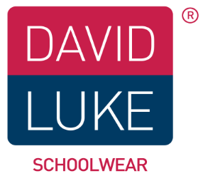
Girl's Junior Trousers  1 pair each girl |  |  |  |  | Black Grey |  |  | Girl's Junior trousers order by age.
 |  |  |  |  |  |  |  | 3/4 4/5 5/6 6/7 7/8 8/9 9/10 10/11 11/12 12/13
Girl's Senior Skirt  1 skirt each girl |  |  |  |  | Navy Grey Black |  |  | Girl's Senior skirt (13yr+) order by waist measurement |  |  |  |  | Length 18" 20" 22" (24" for larger) | Pleated
 |  |  |  |  |  |  |  | 28" 30" |  |  |  |  |  | Straight
Girl's Junior skirt  1 skirt each child |  |  |  |  | Navy Grey Black |  |  | 3/4 4/5 6/7 8/9 9/10 11/12 12/13
Poloshirt  4 for each Girl |  |  |  |  | White Red Sky Gold BottleGreen |  |  | 3/4 4/5 5/6 7/8 9/10 11/12 12/13 34"(S) 36"(M) 38"(L) 42"(XL)
Sweatshirt  1 for each girl |  |  |  |  | Navy Red Royal BottleGreen Maroon Black |  |  | 3/4 4/5 5/6 7/8 9/10 11/12 12/13 34"(S) 36"(M) 38"(L) 42"(XL)
Long Sleeve Blouse  packs of 2 |  |  |  |  | White Blue |  |  | 3/4 4/5 5/6 6/7 7/8 8/9 9/10 10/11 11/12 12/13 32" 34" 36" 38"
Short Sleeve Blouse  packs of 2 |  |  |  |  | White Blue |  |  | 3/4 4/5 5/6 6/7 7/8 8/9 9/10 10/11 11/12 12/13 32" 34" 36" 38"
 | Size Guide
 | Age | Boys Trousers | Girls Trousers | Skirts |  | Polo/Sweats | Shirts (collar) |  |  | Blouses (chest) | Coats | 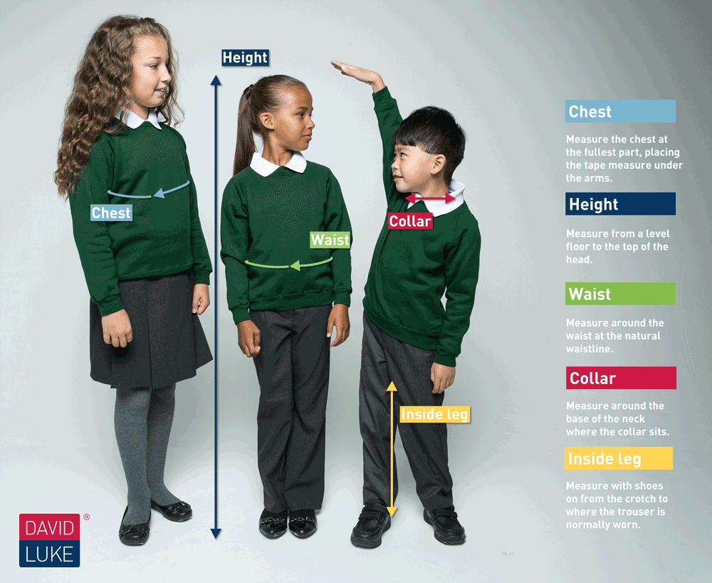
 |  | 20" | 20" |  |  | 18" | 10.5"
 | 3/4 | 20" |  | 20" |  | 20" | 11" |  |  | 22"
 | 4/5 | 21" | 21" |  |  | 22"
 | 5/6 | 22" |  |  |  | 24" | 11.5" |  |  | 24"
 | 6/7 |  | 22" | 22" |  |  | 12"
 | 7/8 | 23" |  |  |  | 26" |  |  |  | 26"
 | 8/9 | 24" | 23" | 24" |  |  | 12.5"
 | 9/10 | 25" | 24" |  |  | 28" | 13" |  |  | 28"
 | 11/12 | 27" | 25" | 26" |  | 30" |  |  |  | 30"
 | 12/13 | 28" | 26" |  |  | 32" | 14"
 | 13 | 29" | 27" | 28" |  | 34" Small |  |  |  | 32"
 | 14 | 30" | 28" |  |  | 36" Medium | 15" |  |  | 34"
 | 15 | 32" | 29" | 30" |  | 38" Large |  |  |  | 36"
 | 16 | 34" | 30" |  |  | 42" X Large | 16" |  |  | 38" |  |  |  |  | *Ages are intended as a Guide*
 | Order Girl's Senior Trousers by waist measurement, with a choice slim leg or regular leg Order Girl's Junior Trousers by age with a choice slim fit or regular fit
 | Order Girl's Senior Skirts by waist measurement and by length 18" 20" 22" and for larger size only 24" Order Girl's Junior Skirts by age
 | Blouses and Shirts are in packs of 2 you may order 2 packs of 2 in any combination for each child (you will receive 4 blouses or shirts for each Child)

