In placing this order you consent to Wood Street Mission sharing your details with David Luke Ltd
Uniform will be delivered to your home and is subject to availability
Parent/Carer Name
Parent/Carer Address
 |  |  |  |  |  |  |  |  |  |  |  |  |  |  | Postcode:
Telephone Number |  |  |  |  |  |  |  |  |  |  |  |  |  |  |  |  | 2024
Boys Date of Birth: |  |  |  |  |  |  |  |  |  | (Circle/highlight appropriate size or age)
Please return the completed order form to Wood Street Mission
Item |  |  |  |  | Colour (Circle Appropriate) |  |  |  |  | Size |  |  |  |  |  | Qty
Boys Senior Trousers 1 pair each boy |  |  |  |  | Black Grey |  |  |  |  | Boys Senior trousers (13yr+) order by Waist measurement. |  |  |  |  |  | Length  Short Regular  Long | 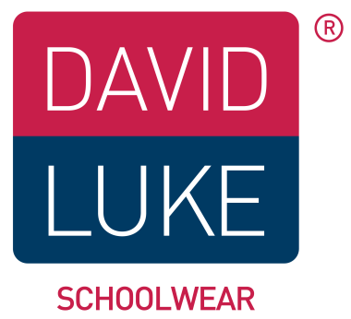
 |  |  |  |  |  |  |  |  |  | 29" 30" 31" 32" 34" 36" 38" |  |  |  |  | Regular leg or Slim leg
Boys Junior Trousers 1 pair each boy |  |  |  |  | Black Grey |  |  |  |  | Boys Junior trousers order by age.
 |  |  |  |  |  |  |  |  |  | 3/4 4/5 5/6 6/7 7/8 8/9 9/10 10/11 11/12 12/13
Poloshirt  4 for each boy |  |  |  |  | White Red Sky Gold BottleGreen |  |  |  |  | 3/4 4/5 5/6 7/8 9/10 11/12 12/13 34"(S) 36"(M) 38"(L) 42"(XL)
Sweatshirt  1 for each boy |  |  |  |  | Black Navy Red Royal BottleGreen Maroon |  |  |  |  | 3/4 4/5 5/6 7/8 9/10 11/12 12/13 34"(S) 36"(M) 38"(L) 42"(XL)
Long Sleeve Shirt packs of 2 |  |  |  |  | White Blue |  |  |  |  | 3/4 4/5 5/6 6/7 7/8 8/9 9/10 10/11 11/12 12/13 14 15 16
Short Sleeve Shirt packs of 2 |  |  |  |  | White Blue |  |  |  |  | 3/4 4/5 5/6 6/7 7/8 8/9 9/10 10/11 11/12 12/13 14 15 16
Size Guide
Age | Boys Trousers |  | Girls Trousers |  |  | Skirts |  | Polo/Sweats |  |  | Shirts (collar) | Blouses (chest) | Coats | 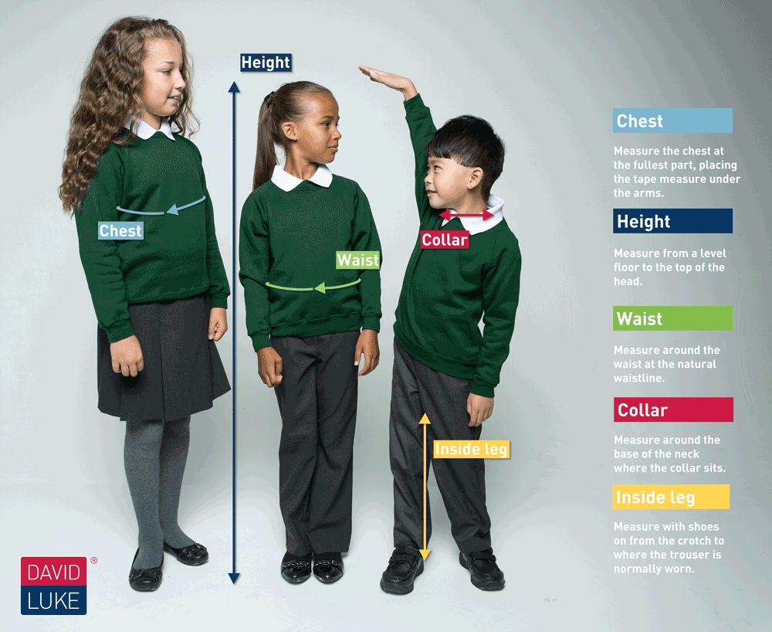
 | 20" |  | 20" |  |  |  |  | 18" |  |  | 10.5"
3/4 | 20" |  |  |  |  | 20" |  | 20" |  |  | 11" | 22"
4/5 | 21" |  | 21" |  |  |  |  | 22"
5/6 | 22" |  |  |  |  |  |  | 24" |  |  | 11.5" | 24"
6/7 |  |  | 22" |  |  | 22" |  |  |  |  | 12"
7/8 | 23" |  |  |  |  |  |  | 26" |  |  |  | 26"
8/9 | 24" |  | 23" |  |  | 24" |  |  |  |  | 12.5"
9/10 | 25" |  | 24" |  |  |  |  | 28" |  |  | 13" | 28"
11/12 | 27" |  | 25" |  |  | 26" |  | 30" |  |  |  | 30"
12/13 | 28" |  | 26" |  |  |  |  | 32" |  |  | 14"
13 | 29" |  | 27" |  |  | 28" |  | 34" Small |  |  |  | 32"
14 | 30" |  | 28" |  |  |  |  | 36" Medium |  |  | 15" | 34"
15 | 32" |  | 29" |  |  | 30" |  | 38" Large |  |  |  | 36"
16 | 34" |  | 30" |  |  |  |  | 42" X large |  |  | 16" | 38" |  | *Ages are intended as a Guide*
Order Boys junior trousers by age with a choice of Slim leg or Regular leg
Order boys Senior trousers by waist measurement with a choice of short, regular or long length.

