“In placing this order, you consent to Wood Street Mission sharing your details with David Luke Ltd”
3 |  |  | Please fill in 1 order form for each child |  |  |  |  |  |  |  |  |  |  | 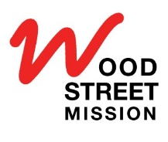  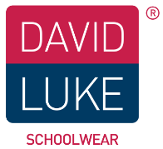  Boys trousers are Short (S), Regular (R) or Long (L) (Circle in “Other” box)  Slim leg (SL) or regular leg (RL) (Circle in “Other” box)
Parent/Carer Name:
Parent/Carer Address:
 |  |  |  |  |  | Postcode:
Mobile Phone:
 |  |  | Uniform will be delivered to your home subject for availability
Child's Date of Birth: |  |  |  |  |  |  | 2020 |  |  | Uniform pack number:
Please return this order form to Wood Street Mission
Item |  |  | Colour (Circle Appropriate) |  |  | Size (Circle Appropriate) |  |  |  |  |  |  | Other
Boys Senior Trousers |  |  | Black, Grey |  |  | 29” 30” 31” 32” 34” 36” 38” 40” 42” 44” |  |  |  |  |  |  | S R L  SL RL
Girls Senior Trousers |  |  | Black, Grey |  |  | 27” 28” 29” 30” 31” 32” 34” 36” 38” |  |  |  |  |  |  | S R L  SL RL | Girl’s junior trousers are Slim fit (SF) or Comfort Fit (CF) (Circle in “Other” box)
Boys Junior Trousers |  |  | Black, Grey |  |  | 2/3 3/4 (Regular length only)  4/5 5/6 6/7 7/8 9/10 10/11 11/12 |  |  |  |  |  |  | SF CF
Girl’s Junior Trousers |  |  | Black, Grey |  |  | 3/4 5/6 6/7 8/9 10/11 11/12 12/13 13 14 15 16 32” 34”” 36” 38” |  |  |  |  |  |  | SF CF | Larger size skirt lengths are 18", 20", 22" or 24”  (Circle in “other “ box).  Pleated or Straight  (Circle here)  Sweatshirts-  Crew or V-neck.  (Circle in”Other “ box)
Girls Skirt |  |  | Navy, Grey, Black |  |  | 3/4 5/6 6/7 7/8 8/9 9/10 10/11 11/12 |  |  |  |  |  |  | 18” 20” 22” 24”
Poloshirt |  |  | White, Red, Sky blue, Gold, Bottle |  |  | 2/3 3/4 4/5 5/6 7/8 9/10 11/12 12/13, 13,  S, M, L, XL
Sweatshirt |  |  | Navy, Red, Royal blue, Bottle green, Maroon, Black |  |  | 3/4 4/5 5/6 7/8 9/10 11/12 12/13 13  S, M, L, XL |  |  |  |  |  |  | Crew neck or V neck
Long Sleeve Shirt |  |  | White, Blue |  |  | 2/3, 3/4, 4/5, 5/6, 7/8, 9/10, 11/12, 12/13, 13, S, M, L, XL
Short Sleeve Shirt |  |  | White, Blue |  |  | 2/3, 3/4, 4/5, 5/6, 7/8, 9/10, 11/12, 12/13, 13, S, M, L, XL
Long Sleeve Blouse |  |  | White, Blue |  |  | 2/3, 3/4, 4/5, 5/6, 7/8, 9/10, 11/12, 12/13, 13, S, M, L, XL
Short Sleeve Blouse |  |  | White, Blue |  |  | 2/3, 3/4, 4/5, 5/6, 7/8, 9/10, 11/12, 12/13, 13, S, M, L, XL
Size Guide
Age | Boys Trousers | Girls Trousers |  | Skirts | Polo/Sweats | Shirts (collar) |  | Blouses (chest) |  |  | Blazers
2/3 | 20" | 20" |  |  | 18" | 10.5"
3/4 | 20" |  |  | 20" | 20" | 11" |  | 22"
4/5 | 21" | 21" |  |  | 22"
5/6 | 22" |  |  |  | 24" | 11.5" |  | 24"
6/7 |  | 22" |  | 22" |  | 12"
7/8 | 23" |  |  |  | 26" |  |  | 26"
8/9 | 24" | 23" |  | 24" |  | 12.5"
9/10 | 25" | 24" |  |  | 28" | 13" |  | 28"
11/12 | 27" | 25" |  | 26" | 30" |  |  | 30" |  |  | 30/32 |  |  |  |  |  |  |  |  |  | 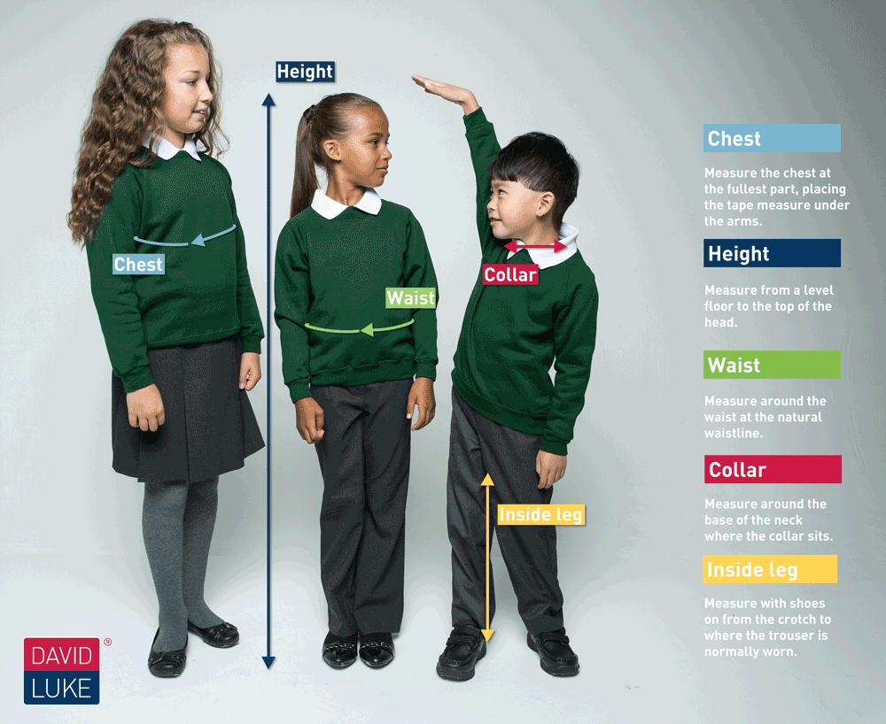
12/13 | 28" | 26" |  |  | 32" | 14" |  |  |  |  | 32
13 | 29" | 27" |  | 28" | 34" (S) |  |  | 32" |  |  | 34/36
14 | 30" | 28" |  |  | 36" (M) | 15" |  | 34" |  |  | 36/38
15 | 32" | 29" |  | 30" | 38" (L) |  |  | 36" |  |  | 38/40
16 | 34" | 30" |  |  | 42" (XL) | 16" |  | 38" |  |  | 42/44
- Order smaller skirts by age and larger skirts by waist measurement. * Skirts are available in length 18”, 20” or 22” (Also 24” for larger)
- Order girl’s senior trousers by waist measurement, with a choice of Slim Leg (SL) or Regular Leg (RL)
- Order girl’s junior trousers by age, with a choice of Slim Fit (SF) or Regular Fit (RF)
- Order boy’s trousers by age (junior) or Waist (senior) with a choice of lengths- Short (S) or Regular (R). Long (L) is for Senior’s only.
- There are two styles of boy’s trousers- Regular Leg (RL) and Slim Leg (SL)

