3 |  |  | Please fill in 1 order form for each child
Parent/Carer Name:
Parent/Carer Address:
Postcode:
Telephone
Child's Date of Birth: |  |  |  |  |  |  |  |  |  | Uniform pack number:
Please return this order form to Wood Street Mission
Item |  |  | Colour (Circle Appropriate) |  |  |  | Size (Circle Appropriate) |  |  |  |  |  | Qty
Boys Senior Trousers |  |  | Black, Grey |  |  |  | 24R, 25R, 27S, 27R, 27L, 28S, 28R, 28L, 29S, 29R, 29L, 30S, 30R, 30L, 32S, 32R, 32L, 34S, 34R, 34L, 36, 38
Girls Senior Trousers |  |  | Black, Grey |  |  |  | 22S, 22R, 22L, 23S, 23R, 23L, 24S, 24R, 24L, 25S, 25R, 25L, 26S, 26R, 26L, 27S, 27R, 27L, 28S, 28R, 28L, 29S, 29R, 29L, 30S, 30R, 30L (goes up in 2's) |  |  |  |  |  |  |  | Trousers are Short (S), Regular (R) or Long (L).  Slim leg or regular leg- (write SL or RL in box)
Boys Junior Trousers |  |  | Black, Grey |  |  |  | 2/3, 3/4, 5/6, 6/7, 7/8, 9/10, 10/11, 11/12
Girls Junior Trousers |  |  | Black, Grey |  |  |  | 3/4, 5/6, 6/7, 7/8, 8/9, 9/10, 10/11, 11/12 |  |  |  |  |  |  |  | Skirt Waist/Skirt Length  Skirt lengths are 18" , 20" or 22"  Sweatshirts- Crew or V-neck- (write C or V in box)
Girls Skirt(waist" / length") |  |  | Navy, Grey, Black |  |  |  | 22/18", 22/20", 22/22", 24/18", 24/20", 24/22", 26/18", 26/20", 26/22", 28/18", 28/20", 28/22", 30/18", 30/20", 30/22" (goes up in 2's)
Poloshirt |  |  | White, Red, Sky blue, Gold, Bottle |  |  |  | 2/3, 3/4, 4/5, 5/6, 7/8, 9/10, 11/12, 12/13, 13, S, M, L, XL
Sweatshirt |  |  | Navy, Red, Royal blue, Bottle green, Maroon, Black |  |  |  | 3/4, 4/5, 5/6, 7/8, 9/10, 11/12, 12/13, 13, S, M, L, XL
Long Sleeve Shirt |  |  | White, Blue |  |  |  | 2/3, 3/4, 4/5, 5/6, 7/8, 9/10, 11/12, 12/13, 13, S, M, L, XL
Short Sleeve Shirt |  |  | White, Blue |  |  |  | 2/3, 3/4, 4/5, 5/6, 7/8, 9/10, 11/12, 12/13, 13, S, M, L, XL
Long Sleeve Blouse |  |  | White, Blue |  |  |  | 2/3, 3/4, 4/5, 5/6, 7/8, 9/10, 11/12, 12/13, 13, S, M, L, XL
Short Sleeve Blouse |  |  | White, Blue |  |  |  | 2/3, 3/4, 4/5, 5/6, 7/8, 9/10, 11/12, 12/13, 13, S, M, L, XL
Size Guide
Age | Boys Trousers | Girls Trousers |  | Skirts | Polo/Sweats | Shirts (collar) |  |  | Blouses (chest) |  | Blazers
2/3 | 20" | 20" |  |  | 18" | 10.5"
3/4 | 20" |  |  | 20" | 20" | 11" |  |  | 22"
4/5 | 21" | 21" |  |  | 22"
5/6 | 22" |  |  |  | 24" | 11.5" |  |  | 24"
6/7 |  | 22" |  | 22" |  | 12"
7/8 | 23" |  |  |  | 26" |  |  |  | 26"
8/9 | 24" | 23" |  | 24" |  | 12.5"
9/10 | 25" | 24" |  |  | 28" | 13" |  |  | 28"
11/12 | 27" | 25" |  | 26" | 30" |  |  |  | 30" |  | 30/32 |  |  |  |  |  |  |  |  |  |  | 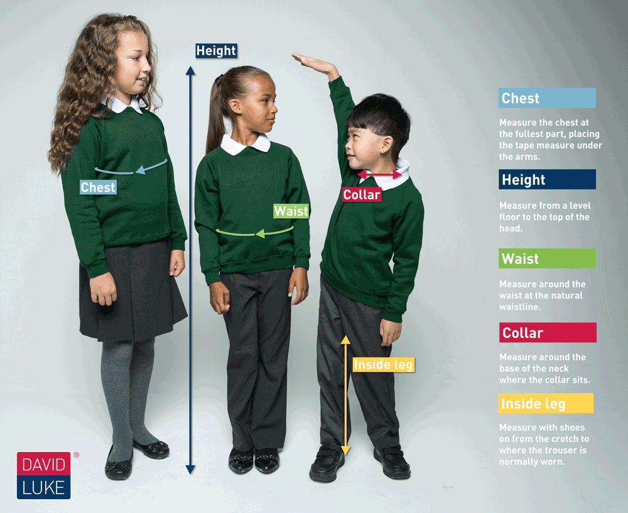
12/13 | 28" | 26" |  |  | 32" | 14" |  |  |  |  | 32
13 | 29" | 27" |  | 28" | 34" (S) |  |  |  | 32" |  | 34/36
14 | 30" | 28" |  |  | 36" (M) | 15" |  |  | 34" |  | 36/38
15 | 32" | 29" |  | 30" | 38" (L) |  |  |  | 36" |  | 38/40
16 | 34" | 30" |  |  | 42" (XL) | 16" |  |  | 38" |  | 42/44
*Skirts sizes are waist and length measurements (waist" size 1st / length" 2nd)
*Skirts are available in length 18", 20" or 22"
*Trousers sizes are Waist and Short(S)length, Regular(R) length, or Long(L) length
*Ages are intended as a guide. Measuring is more reliable method.

